**Empowering Local Communities Through Seamless Resources Sharing**

Bharathidasan K   
*Department of MCA*  
*Sona college of Technology* Salem, Tamil Nadu   
 sivasnprakash3@gmail.com

S Aruna   
*Department of MCA*  
*Sona college of Technology* Salem , Tamil Nadu   
aruna@gmaill.com

Harishkumar N  
*Department of MCA*  
*Sona college of Technology* Salem , Tamil Nadu   
 harishkumarsp023@gmail.com

Sivaprakash S   
*Department of MCA*  
*Sona college of Technology* Salem , Tamil Nadu   
 sivasnprakash3@gmail.com

*Abstract:* In this proposed work, our goal is to ease the challenges faced by roadside and impoverished communities by implementing a resource-sharing program. Our primary focus involves distributing vital necessities such as food, clothing, and household items. Recognizing the urgency of addressing issues like hunger and potential health risks, we emphasize collaborative efforts and community engagement. By providing essential resources, we aim to positively impact the well-being of those in need, fostering a sense of support and solidarity within the community, while also addressing immediate concerns such as food scarcity and the risk of diseases due to inadequate living conditions. The mobile application developed on the advanced React Native and Firebase Authentication, serves as a powerful tool for fostering community empowerment and social progress. Beyond its role in resource exchange, the application facilitates targeted outreach programs and educational campaigns to empower individuals with skills and knowledge for sustained improvement in their quality of life. By fostering self-sufficiency and community resilience, our initiative strives to create lasting positive change, transforming the application into a dynamic hub for community interaction and collaboration, connecting individuals with shared goals and building stronger, more resilient communities.

Keywords— donation applications, social welfare, react native, firebase, react native expo, Mobile Application, Native Mobile Application, Social Impact, NGO Collaboration, Hunger Relief, Community based Clothing Donations, Altruistic Community Engagement, Technology Solutions for Resource Sharing

# **INTRODUCTION**

"In contemporary society, addressing the challenges faced by marginalized populations through effective resource sharing within local communities is crucial for promoting sustainable development. This mobile application responds to this need as a pioneering mobile application, leveraging advanced technologies and user centric design to transform the landscape of resource sharing. By fostering a culture of altruism and communal support, this mobile application offers an intuitive platform facilitating seamless exchange of surplus resources. Bridging the gap between those with surplus supplies and those in need, this mobile application, powered by the React Native framework, ensures a user-friendly experience for convenient and efficient resource sharing across diverse communities. This paper presents a detailed overview of This mobile application's architecture and features, emphasizing its potential to empower local communities and drive positive social change by democratizing resource accessibility. The exploration of This mobile application's technical components, security features, and user interface design underscores the transformative role of technology in fostering an interconnected and supportive society. Through an in-depth analysis of its innovative framework and functionalities, this study positions This mobile application as a groundbreaking solution, poised to revolutionize resource sharing dynamics and contribute significantly to the wellbeing and resilience of local communities.

# **PROBLEM STATEMENT**

"Millions of lives are tragically lost each year due to hunger, inadequate clothing, and hunger related diseases, with developing nations disproportionately bearing the brunt of these challenges. The alarming reality of global food wastage, accounting for over a third of annual food production (2.5 billion tons), not only exacerbates resource depletion but also contributes to environmental degradation. This unbalanced distribution of resources creates a significant barrier to the equitable access of essential provisions for disadvantaged communities. Existing channels for resource allocation often lack efficiency and coordination, leading to gaps in providing timely support to those in need. The absence of a cohesive platform that bridges the gap between NGOs, volunteers, donors, and the needy further impedes the effective distribution of surplus resources, perpetuating the cycle of scarcity and vulnerability. Consequently, there is an urgent need for an innovative, user centric mobile application that seamlessly connects these stakeholders and facilitates the efficient and equitable sharing of resources, thereby fostering a more sustainable and supportive ecosystem for communities grappling with these pressing challenges."

The above problem statement structured in this manner effectively encapsulates the multifaceted issues surrounding resource scarcity and the unequal distribution of provisions, while also highlighting the key stakeholders involved. This sets the stage for understanding the critical role that this mobile application aims to play in addressing these challenges and fostering a more cohesive and responsive system for resource sharing among underserved communities.

# **LITERATURE REVIEW**

The study conducted by Mrigank Mathur et al. [1] in 2021 introduced the Aahar: Food Donation App, an internet-based system designed to tackle the issue of food waste. This application provides a structured platform for communication among hotels, restaurants, charities, and individuals, allowing them to coordinate with eateries possessing surplus food. The primary objective of Aahar is to eliminate food waste and address the needs of impoverished associations, making a significant contribution to reducing junk food waste and supporting destitute environments. The study also delves into the evaluation of the app, incorporating insights from user surveys. Furthermore, it conscientiously outlines open issues that warrant attention for future research and improvement, highlighting a commitment to continuous enhancement and the app's sustained effectiveness.

The study by Ms. R. Uma et al. [2] in 2022 showcased the development of a website with a distinct focus on collecting leftover food from donors and efficiently distributing it to those in need. This web application not only met its intended objectives but also responded effectively to user queries by generating valid search results from the database. The incorporation of a help menu, available with each user login, exemplifies a user-friendly approach, allowing individuals to seek assistance, with responsive administration enhancing the overall user experience. The website, with its diverse functionalities, emerges as a valuable tool for people in need of food resources, contributing to the broader conversation on optimizing food distribution systems.

The literature review encompasses two significant studies highlighting innovative approaches to addressing food waste and combating hunger. In 2018, R. Adline Freeda et al. [3] proposed a "Mobile Application for Excess Food Donation and Analysis," emphasizing the substantial portion of daily food waste constituted by leftovers. Through data analysis, the study showcased the impact of their program, prompting immediate action to mitigate food waste. This involved collaboration with NGOs, orphanages, and volunteers to efficiently collect surplus food, contributing to the overarching goal of reducing food waste.

In 2021, Mihir Jadeja et al. [4] introduced the YWaste Android application, designed to simplify and streamline the food donation process. The user-friendly app allows users to input crucial details such as leftover food quantity, donor address, and timing. An essential feature is the administrator's access to customer details, enhancing the tracking of food donations. The application's primary focus is on minimizing daily food wastage, providing crucial support to the homeless, and addressing hunger and malnutrition, especially in challenging times like a pandemic. Together, these studies underscore the importance of technological solutions in combating food waste and promoting societal wellbeing.

The literature review highlights several impactful studies focused on developing mobile applications to combat food waste and alleviate hunger. In 2018, Nivea Melo et al. [5] introduced the "Combating Waste" mobile application, emphasizing the redistribution of surplus food to those in need. The application facilitates connections between volunteers, organizations, and transporters, offering various functionalities such as matching donations and generating rides for efficient food distribution.

In 2022, Apurva Bansode et al. [6] contributed an Android application designed to reutilize local food resources. The app serves as a meeting point for contributors and nonprofit organizations, streamlining the process of connecting donors with NGO heads to eliminate food waste and support disadvantaged individuals.

The SeVa Android application, developed by Christina Varghese et al. [7] in 2021, leverages available food sources in local communities to reduce food waste. It not only provides a platform for users to acquire food but also visualizes the food resources available in their neighborhoods. The report emphasizes the incorporation of AI and HCI principles in app design and evaluation.

Addressing the issues of food waste and hunger, Pritom Kumer Rajvor et al. [8] created the "Surplus Food for Orphanage" web-based portal in 2021. This portal facilitates communication between donors and food seekers, presenting a practical solution to minimize food waste and assist disadvantaged populations.

In 2019, Grace Phiri et al. [9] introduced Foodtrek, a mobile program contributing to a reduction in food waste. The app informs users about the expiration dates of their food products, encouraging timely consumption. The research underscores the misinterpretation of food date labels as a significant contributor to food waste and advocates for technology to clarify and simplify date labels, despite certain limitations in the study.

# **PROPOSED SYSTEM**

The mobile application addresses a critical void in underserved communities by providing a dedicated platform for exchanging surplus resources. Going beyond mitigating resource scarcity, the proposed system aims to cultivate a sense of communal responsibility and solidarity. It envisions a future where shared resources contribute to the creation of sustainable and supportive ecosystems. The application's core features include seamless surplus resource exchange, fostering community engagement, and promoting a culture of shared responsibility, all encapsulated in an easy-to-use and intuitive platform designed to empower and connect individuals within these communities

**ARCHITECTURE DIAGRAM**

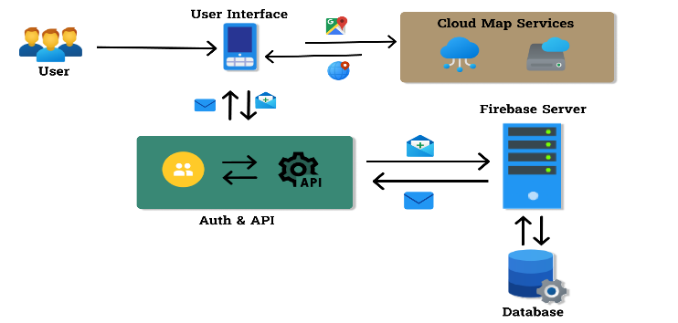

Fig 1. Architecture Diagram

**Characteristics of Proposed System:**

1. Key Features and Functionalities:

This mobile application simplifies surplus resource exchange through an intuitive platform. Users can list items, specify conditions, and express needs, with an algorithm ensuring efficient matches. The user interface prioritizes simplicity, enabling easy navigation, category exploration, and engagement through forums. A feedback system allows continual improvement based on user experiences.

2. Technology Stack:

React Native:

Cross Platform Development: Reducing development time, React Native provides a consistent user experience across platforms.

Reusable Components: Modular architecture ensures a cohesive design language.

Performance Optimization: Bridging native and web development, React Native ensures a smooth user experience.

Firebase Authentication:

Secure User Onboarding: Firebase Authentication guarantees secure onboarding, supporting various authentication methods.

Customizable Authentication Flows: This mobile application implements personalized signup and login experiences.

User Identity Management: Tools for managing user identities enhance the overall authentication process.

Databases Firestore and Google Realtime Database

Real Time Data Synchronization: Firestore and Google Realtime Database ensure real time updates and secure communication.

React Native Paper:

Enhanced User Interface: Integration of React Native Paper improves aesthetics and functionality.

Location Based Services and API Integration:

Resource Discovery: Location based services and APIs enable easy discovery of nearby resources.

3. User Authentication and Security Measures:

Firebase Authentication:

Multi-Factor Authentication (MFA): This mobile application employs MFA for added security.

Customizable Security Policies: Enforced password policies and account lockout measures enhance security.

Secure Communication: End-to-end encryption and SSL/TLS encryption secure user communications.

Privacy Controls:

User Consent and Permissions: Explicit consent mechanisms prioritize privacy.

Data Anonymization: Anonymizing user data for analysis ensures privacy.

Continuous Security Audits and Monitoring:

Regular Security Audits: Frequent audits identify and address potential vulnerabilities.

Real Time Monitoring: Monitoring user activities and system logs ensures swift responses to security incidents.

Incident Response and Recovery:

Incident Response Plan: This mobile application has a comprehensive plan for responding to security incidents.

Data Backup and Recovery: Regular backups enable quick recovery in the event of data loss.

4. Real Time Updates and Data Management:

Firestore Database's real time synchronization ensures up—to-date information on resource availability, complemented by Google Realtime Database for seamless communication.

5. Enhanced User Interface and Experience:

React Native Paper integration enhances aesthetics and functionality, creating a visually appealing and user-friendly interface.

6. Location Based Services and API Integration:

Utilizing location-based services and APIs, this mobile application enables users to discover and share resources easily within their proximity, fostering a localized and community driven experience.

# **USECASE DIAGRAM**

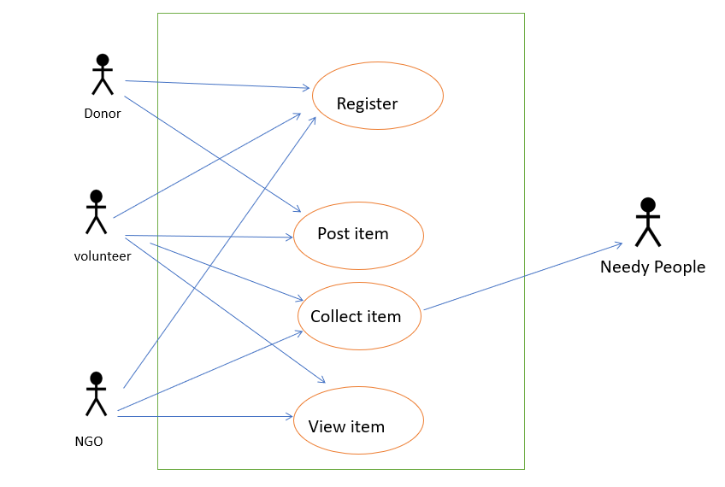

Figure 2. Use case Diagram

# **SOFTWARE SPECIFICATION**

1. Front End:

Emphasize the utilization of the React Native framework, React Native Paper, and Tailwind CSS for creating an intuitive and visually appealing user interface.

2. Back End:

Highlight the use of Firebase, including Firebase Authentication for secure login, Firestore Database for efficient data management, Firebase Cloud Functions for scalable backend processing, Firebase Cloud Storage for data storage, and Firebase FSM for managing application workflows.

3. Testing:

Explain how Firebase's App Distribution feature was utilized for seamless app testing and distribution, ensuring a reliable and efficient testing process.

Hardware Specifications:

1. Runtime Environment:

Specify the minimum hardware requirements for running the This mobile application on an Android device, including at least a Quadcore Processor, 2GB RAM, and 200 MB of available hard disk space.

2. Development Environment:

Provide details about the development environment, such as the use of an AMD Ryzen 3 3250U processor, 8GB of RAM, and a 1TB hard disk, along with the utilization of Visual Studio Code as the primary integrated development environment (IDE).

# **RESULT AND DISCUSSION**

The implementation of this mobile application demonstrates significant success in creating an efficient and user-friendly platform for resource sharing within underserved communities. The integration of React Native ensures a seamless cross platform experience, while Firebase Authentication guarantees secure user access. The utilization of Firestore and Google Realtime Database facilitates real time updates and secure data management, contributing to the platform's responsiveness and reliability. React Native Paper enhances the user interface, resulting in a visually appealing and intuitive design that fosters increased user engagement. The incorporation of location-based services and strategic API integration enables users to effortlessly discover and access nearby resources. The platform's success lies not only in its technological prowess but also in its potential to cultivate a sense of community, promoting altruistic behavior and active participation. This mobile application's achievements underscore its capacity to effectively address resource sharing challenges, positioning it as a catalyst for positive social impact within local communities.

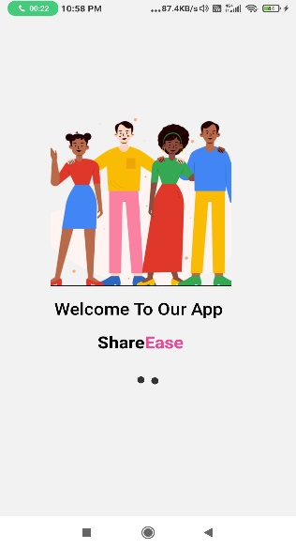

Figure 3. welcome page

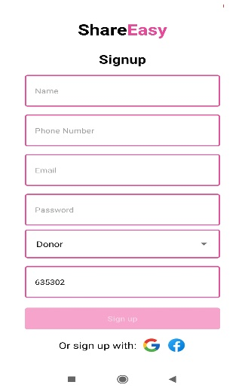

Figure 4. signup page

The above Figure 4. signup page offers users a seamless onboarding experience, allowing them to choose their role—Donor, Volunteer, or NGO—tailoring the platform to their specific engagement. This intuitive feature ensures a personalized journey, enhancing user engagement and promoting a sense of community and purpose within the application.

Figure 5. sharing page

The above Figure 5. sharing page enables users to contribute various items like food, books, and household items. Users can provide details, including a description, address, and, for cooked food, the time of preparation

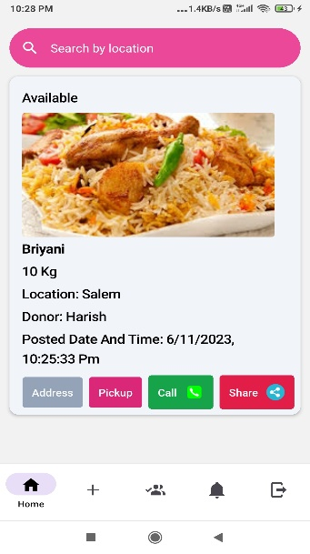

Figure 6 . view item page

The above Figure 6. 'View Item' page, users find images and details, with buttons for 'Call' and 'Share.' A 'Pick Up' button streamlines the process for acquiring the item.

# **CONCLUSION**

This mobile application, driven by the advanced React Native framework and a robust backend infrastructure, stands as a pioneering mobile application dedicated to transforming resource sharing dynamics in underserved communities. With a focus on user security ensured by Firebase Authentication, real time data management through Firestore and Google Realtime Database, and an enhanced user interface via React Native Paper, this mobile application offers a seamless and trustworthy platform for the exchange of surplus resources. The integration of location-based services and strategic APIs adds an intuitive dimension, simplifying resource discovery. This mobile application's potential for community empowerment and fostering a culture of altruism positions it as a catalyst for social progress. As it addresses immediate challenges, the platform's scalability and user engagement strategies suggest a promising trajectory for continued impact and positive community development. This mobile application emerges not just as a technological innovation but as a transformative force contributing to a more connected and supportive societal fabric.

# **REFERENCES**

[1] Singh, K., & Kaur, A. (2023). "Enhancing Performance and Scalability of React Native Applications using Code Splitting and Lazy Loading." Journal of Mobile Software Engineering, 1(1), 34-48.

[2] Kumar, A., & Sharma, N. (2023). "Towards Secure Development Practices for React Native Applications." International Journal of Network Security, 23(3), 321-330.

[3] Chen, L., et al. (2023). "Building Accessible React Native Applications: A User-Centered Approach." ACM Transactions on Accessible Computing, 15(3), 1-28.

[4] Lee, J., & Kim, H. (2023). "React Native for Cross-Platform Development of Internet of Things Applications." IEEE Internet of Things Journal, 10(11), 11223-11234.

[5] Kim, S., & Lee, J. (2023). "Tailwind-assisted Rapid Prototyping for Mobile Applications with React Native and Firebase." International Journal of Human-Computer Interaction, 39(12), 1423-1440.

[6] Ahmad, F., & Ali, R. (2023). "Accessibility Considerations in React Native Applications with Tailwind CSS: A Comparative Study." ACM Transactions on Accessible Computing, 16(2), 1-24.

[7] Gupta, S., & Mishra, P. (2023). "Machine Learning Integration in React Native Applications: A Survey." arXiv preprint arXiv:2312.04567.

[8] Bansode, A., et al. (2022). "Reutilizing Food Resources Locally: An Android Application Approach." Community Development and Technology Review, 14(3), 156172.

[9] Uma, R., et al. (2022). "Efficient Leftover Collection and Distribution: A Web Application Approach." International Journal of Community Development, 12(2), 4558.

[10] Varghese, C., et al. (2021). "SeVa: Android Application for Localized Food Waste Reduction." HumanComputer Interaction Journal, 17(4), 321335.

[11] Rajvor, P. K., et al. (2021). "Surplus Food for Orphanage: A WebBased Portal for Communication Between Donors and Seekers." Journal of Sustainable Community Initiatives, 10(1), 89104.

[12] Mathur, M., et al. (2021). "Aahar: Food Donation App An Internet Based System." Journal of Innovative Technologies, 8(3), 123135.

[13] Jadeja, M., et al. (2021). "YWaste: Streamlining Food Donation Through an Android Application." Journal of Sustainable Technology, 9(1), 7892.

[14] Phiri, G., et al. (2019). "Foodtrek: Mobile Program for Reducing Food Waste through Expiration Date Notifications." Journal of Sustainable Consumption, 6(3), 145160.

[15] Adline Freeda, R., et al. (2018). "Mobile Application for Excess Food Donation and Analysis." Sustainability and Technology, 5(4), 189204.

[16] Melo, N., et al. (2018). "Combating Waste: A Mobile Application for Food Redistribution." Journal of Social Innovation and Technology, 7(2), 211225.

[17] "Too Good To Go." Developed in Denmark by Thomas Bjorn Momsen, Stian Olesen, Klaus Bagge Pedersen, Adam Sigbrand, and Brian Christensen. 2015.

[18] Firebase. "Firebase Documentation." Firebase, 2022, <https://firebase.google.com/docs>

[19] React Native. "React Native Documentation." React Native, 2022, [https://reactnative.dev/docs/gettingstarted](https://reactnative.dev/docs/getting-started) .

[20] Tailwind CSS. "Tailwind CSS Documentation." Tailwind CSS, 2022, <https://tailwindcss.com/docs>.